Level 2 Teaching Assistant

Information for Applicants

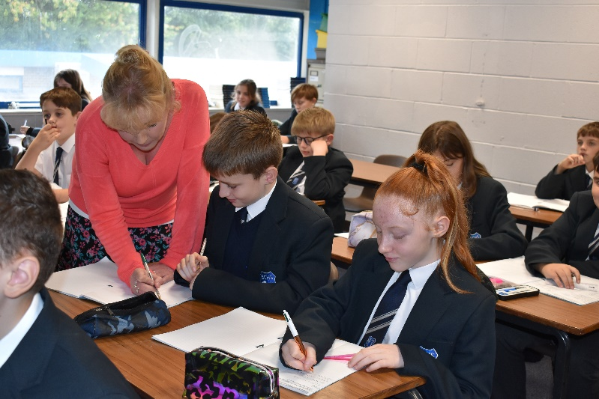

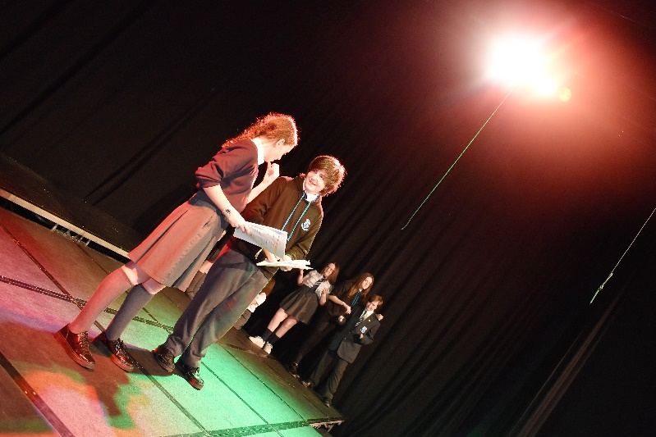

Letter from the Headteacher

Dear Applicant,

This is a truly exciting opportunity for someone who is looking to be part of our Inclusion Team, and who is ready for the responsibility of such an important part of our college journey. BCHS and BC are an amazing school and an amazing college, with a unique sense of spirit and community – they are warm and welcoming, people-focused, and totally dedicated to the community that we serve.
Our staff are passionate about education and believe that all young people should be inspired to be the very best that they can be. Our vision and values articulate the things that we know are important and encapsulate the school’s spirit: we are a team. The staff know this, our parents/carers know this and, most importantly, our students know this.

We pride ourselves on the ethos of our school being underpinned by the strongest foundations of discipline, respect, tolerance, and compassion – we ensure our students are equipped with a strong moral compass. We offer a very strong extra-curricular programme with every member of teaching staff offering a provision, it is an aspect of our school community that we are very proud of, and rightly so.
Our college is currently undergoing a lot of change including us preparing for the delivery of T-Levels for the first time in September 2022. This role will play a key part in our ongoing transformation.
It is essential that we appoint the right person to this role, and it is important that their values and views align with what we are trying to achieve as well as our philosophy on staff wellbeing and development. I would recommend that your read my personal blog (https://leadership-life.co.uk), our school blog (https://www.birchwoodhigh.org/nexilis/) to really give you a more comprehensive insight into how these views and values translate into our day to day processes and habits.

We know that our students are excellent people, and they thrive in a culture of achievement and success; we have high expectations, encouraging them to be aspirational in their learning and to enjoy all aspects of school life. Academic and behaviour standards at BCHS and BC are good for all students irrespective of their starting point. However, we know that we are all capable of even more. We continue to strive to improve levels of student achievement and conduct to move towards being recognised as outstanding in all areas.

Please feel welcome to come and have a visit before applying, but be assured that whether you visit or not, it will not affect the short-listing process. If you would like to have a look round, please email my PA, Jane Calderbank (jcalderbank@birchwoodhigh.org) to arrange.

Thank you for considering our truly amazing school and college as the next chapter in your career, and hopefully I will be reading your application soon.

Yours sincerely,
Emma Mills
Headteacher

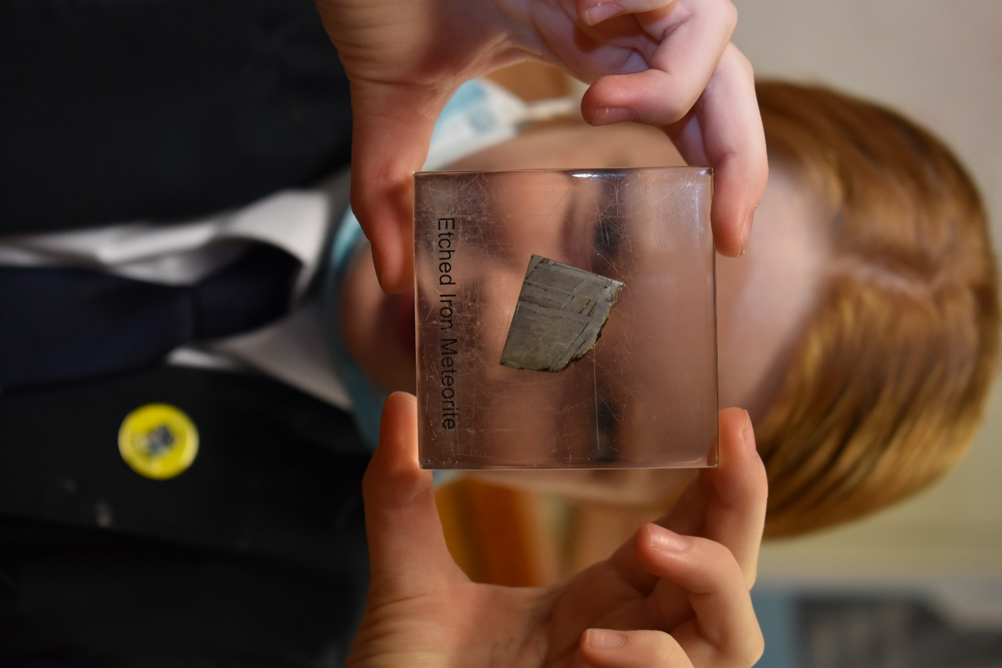

‘There is a ‘buzz’ of energy in classes, reflecting pupil’s positive attitudes to their learning.’

Our Vision

Team Birchwood believe in the power of aspiration, knowledge and kindness. We know that we achieve our best when we work together.

Our Ethos

High aspirations, high expectations and high achievement rely upon a positive working environment based upon respect. For us, respect means consistent positive regard for everyone in our learning community. A strong moral purpose enables students in our school to grow into independent, responsible young adults who can access a happy and healthy future.

At Birchwood we strive to ensure that every lesson counts, for every child, every day. We expect teachers to deliver engaging lessons that ensure students acquire powerful knowledge and develop both essential and desirable skills. For this to happen, behaviour must enable every teacher to teach and every child to learn. We expect students to come ready each day to challenge themselves to be the very best they can be. We have a wide variety of extra-curricular activities to help children develop all their skills and talents and there are many opportunities to develop their leadership skills throughout
their school life.

Our Mission

We are 100% committed to our students. We seek to sustain a community that is rooted in respect and the belief that every student can succeed. We endeavour to equip our young people with the qualities, qualifications and values that will enable them to lead fulfilling lives and become responsible citizens. We want the children in our care to leave us with high aspirations, secure knowledge and a kind heart.

We maintain high standards of ethics and behaviour; one of the ways this is by embracing the British Values: democracy; the rule of law; individual liberty and mutual respect; and tolerance of those with different faiths and beliefs.

Our Aims

We wish for our students to be:

- safe, happy and cared for in a secure and supportive environment.
- supported and challenged to do their best through excellent teaching, a broad and balanced curriculum and a wide variety of experiences.
- recognised, celebrated and rewarded for all their achievements that they develop confidence and independence.
- developed emotionally, intellectually and morally so that they are able to be successful in the rapidly changing, multicultural society in which we live.
- successful, whether through academic qualifications or a more vocational route, so they can move on to the next stage in their life.

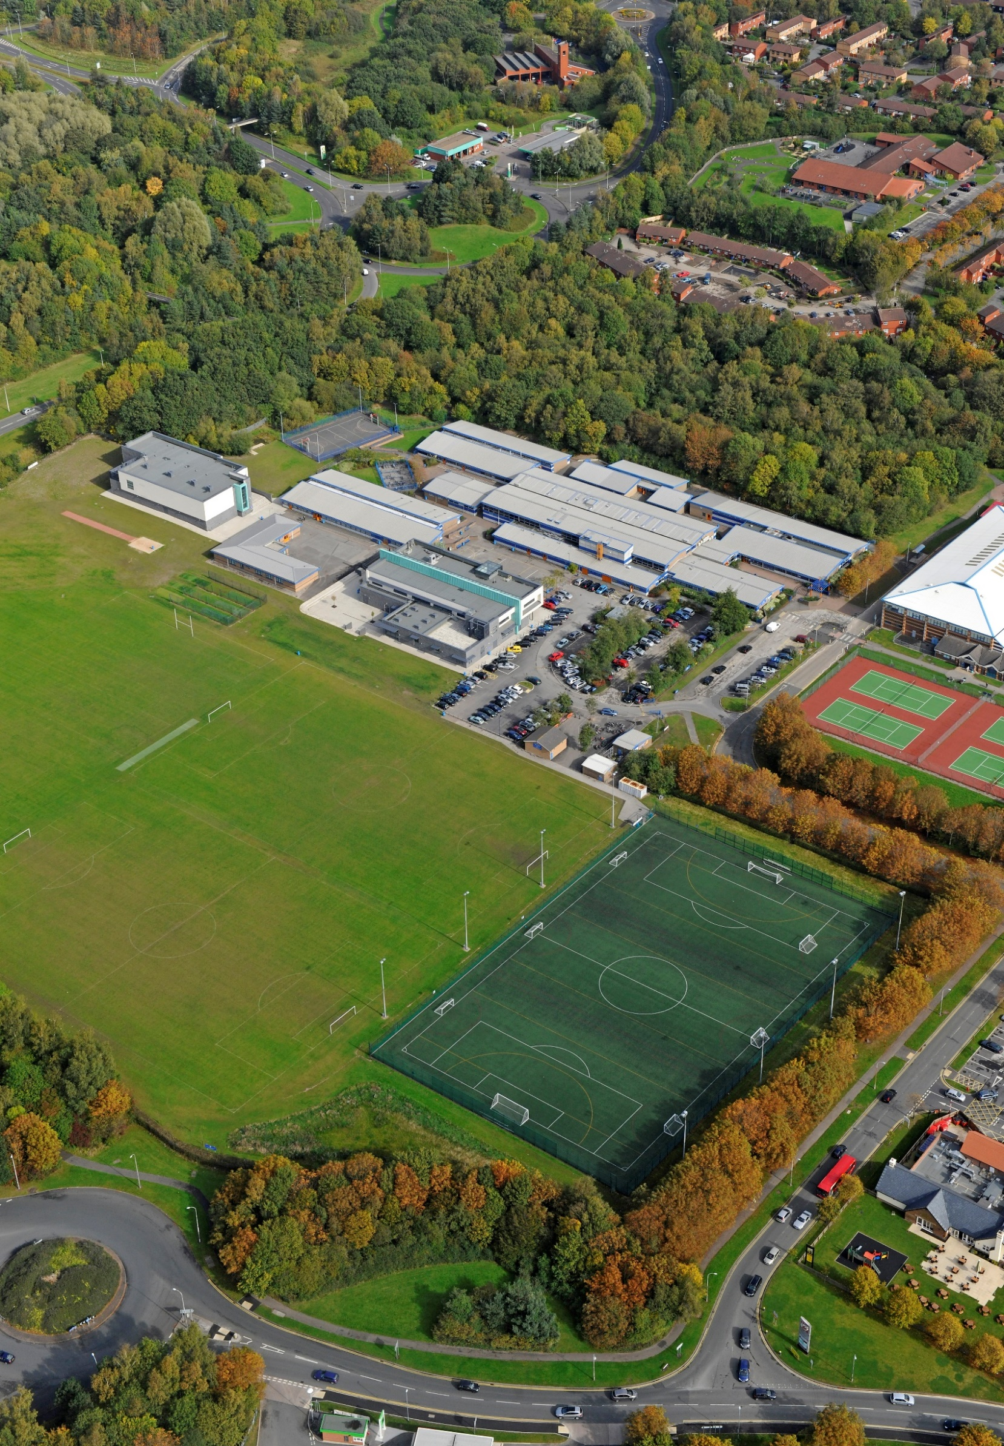

School Profile

- The school became a Single Academy Trust on 1 July 2013.
- The school is of an average size with 904 currently on roll.
- The most recent OFSTED inspection (October 2018) judged the school to be Good in all areas.
- In September 2010, the school opened a sixth form, Birchwood College. Level 3 Applied outcomes and resit Level 2 English and maths outcomes are a strength of the school with some of the highest scores in the North West.
- The percentage of students on the Pupil Premium register is 31%, which is above the national average.
- The proportion of students with SEND (ECHP) is in-line with the national average.
- Most students are of white British heritage.
- Students arrive at the school with outcomes broadly in line with national averages.

Job Description

DEPARTMENT: SUPPORT
POST TITLE: TEACHING ASSISTANT (LEVEL 2)
REPORTS TO: SENCO

MAIN PURPOSE

To work with and supervise individuals and groups of students under the direction/instruction of teaching and/or senior staff, inclusive of specific individual learning needs, enabling access to learning for all students and assistance and support in classroom management and behaviour techniques. Work may be carried out in the classroom or outside the main teaching area.

JOB PROFILE
SUPPORT FOR THE STUDENT
- Establish good constructive working relationships with students, acting as a role model.
- Be aware of and respond appropriately to individual student needs ensuring effective interaction.
- Provide specific support to students, dependent upon their individual needs ensuring their safety whilst supporting access to learning activities.
- Promote inclusion and acceptance of all students.
- Encourage students to interact with others and engage in activities led by the teacher.
- Promote self-esteem and independence.
- Provide feedback to students in relation to progress and achievement under the guidance and direction of the teacher.

SUPPORT FOR THE TEACHER
- Provide minimal clerical/administration support (eg photocopying, typing filing, collecting money etc).
- Assist with the display of children’s work.
- Create and maintain a purposeful, orderly and supportive environment, in accordance with lesson plans.
- In liaison with the teacher, utilise strategies to support students in achieving learning goals.
- Report student achievements, progress and issues as appropriate in agreed format.
- Undertake student record keeping as requested.
- Administer routine tests and invigilate exams & undertake routine marking of students’ work
- Promote good student behaviour, dealing promptly with conflict and incidents and encouraging students to take responsibility for their own behaviour in line with established school policy.
- Establish constructive relationships with parents/carers.

SUPPORT FOR THE CURRICULUM
- Undertake structured and agreed learning activities/learning programmes, taking into consideration student learning styles, adjusting activities according to student responses
- Undertake literacy/numeracy programmes, recording achievements and progress and providing appropriate reports and feedback for the teacher.
- Support the use of ICT in learning activities and develop students’ competence and independence in its use.
- Prepare, maintain and use equipment/resources required to meet the lesson plans/relevant learning activity and assist students in their use.

SUPPORT FOR THE SCHOOL
- Be aware of and comply with school policies and procedures relating to child protection, health, safety and security, confidentiality and data protection. Report all concerns to the appropriate person (as named in the policy concerned).
- Be aware of and support difference and ensure all students have equal access to opportunities to learn and develop.
- Contribute to the school ethos, aims and development/improvement plan.
- Appreciate and support the role of other professionals.
- Attend and participate in relevant meetings as required.
- Participate in training and other learning activities and performance development as required.
- Assist with the supervision of students out of directed lesson time, including before and after school if appropriate and within working hours.
- Accompany teaching staff and students on visits, trips and out of school activities as required and take responsibility for a group under the supervision of a teacher.

The post holder may reasonably be expected to undertake other duties commensurate with the level of responsibility that may be allocated from time to time.

PERSON SPECIFICATION

POST TITLE: TEACHING ASSISTANT (LEVEL 2) GRADE: GR4

SKILLS E-ESSENTIAL D=DESIRABLE

- Ability to work effectively within a team environment, understanding classroom roles and responsibilities |  | E
- Ability to build effective working relationships with all students and colleagues |  | E
- Ability to promote a positive ethos and role model positive attributes |  | E
- Ability to work with children at all levels regardless of specific individual need |  | E
- Good personal numeracy and literacy skills |  | E
KNOWLEDGE & UNDERSTANDING

- General understanding of national curriculum and other basic learning programmes/strategies (within specified age range/subject area) |  | E
- General awareness of inclusion, especially within a school setting |  | E
- Experience of resources preparation to support learning programmes |  | D
- Effective use of ICT to support learning |  | E
- Understanding of other basic technology – video, photocopier |  | D
- Understanding of relevant policies/codes of practice & awareness of relevant legislation |  | D

QUALIFICATIONS
- Minimum 2 years’ experience of working with and /or caring for children with specified
age range/subject area or NVQ II or equivalent in teaching assistance E

- Above within an education setting D

- Requirement to complete DfE Teaching Assistant induction programme E

- Willingness to participate in relevant training and development opportunities E

- Training in literacy/ numeracy strategy D

- Training is special education needs strategy’s E

- Willingness to undertake appointed person certificate in first aid administration D

PROFESSIONAL VALUES AND PRACTICE

MUST BE ABLE TO DEMONSTRATE ALL OF THE FOLLOWING

- High expectations of all students; respect for their social, cultural, linguistic, religious and ethnic backgrounds; and commitment to raising their educational achievements

- Ability to build and maintain successful relationships with students, treat them consistently, with respect and consideration, and demonstrate concern for their development as students

- Demonstrate and promote the positive value, attitudes and behaviour they expect from the students with whom they work

- Ability to work constructively and collaboratively with colleagues, and carry out role effectively, knowing when to seek help and advice

- Able to liaise sensitively and effectively with parents and carers, recognising role in students’ learning

- Ability to improve their own practice through observations, evaluation and discussion with colleagues.

Directions to Birchwood Community High School,
Brock Road Birchwood Warrington WA3 7PT Tel: 01925 853500

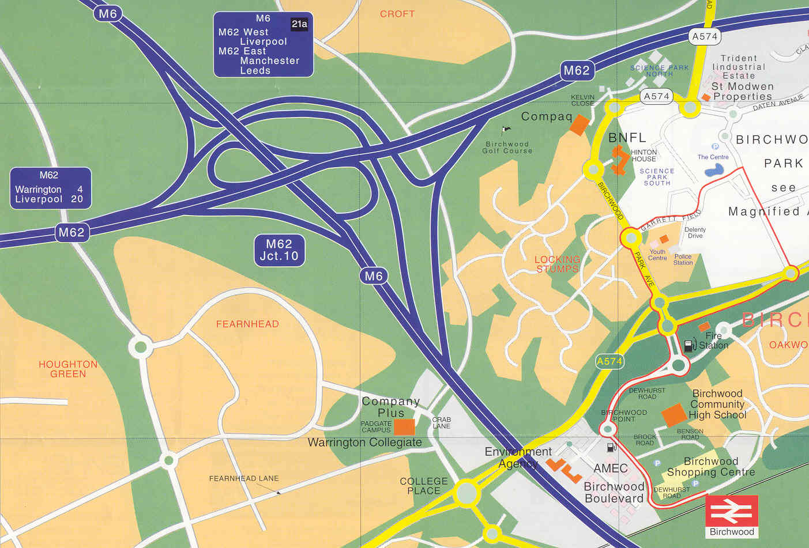

Directions from Manchester.
Exit M62 at junction 11.
Take A574 (Birchwood Way) as far as the 3rd roundabout.
Take first left (Oakwood Gate) to next the roundabout, following signs for Birchwood Centre & Station.
Exit to the right (Dewhurst Road) and follow the road round.
At small roundabout go straight on.
Take first left into Benson Road.
Take first left into Brock Road.
The school and library are the blue and white buildings to the left.

Directions from Chester.
Exit M6 at junction 21.
Take the B5210 (Woolston Grange Avenue), go straight through several roundabouts until the roundabout after the pink footbridge (College Place)
Turn right, joining the A574 (Birchwood Way). At next roundabout, turn right (Oakwood Gate).
Follow directions as from Manchester.

Directions from Warrington.
Take the A49 (Winwick Road) and follow to junction 9 of M62.
Exit M62 at junction 11.
Follow directions as from Manchester.

Directions from Birchwood Train Station
Exit the Station and cross the car park towards the Shopping Centre. Walk through the shopping centre and out the other side exiting into another car park (with McDonald’s in it). Opposite the car park there are 4 tennis courts – pass with the tennis courts on your left. The school and library are the blue and white buildings ahead of you. This is a 5-minute walk.

VISITORS – PLEASE NOTE The Shopping centre car park opposite school operates an ANPR number plate recognition system maximum parking is strictly 3 hours
Pay and display is located near the train station

Birchwood Community Academy Trust
Brock Road
Birchwood
Warrington
Cheshire
WA3 7PT
01925 853500
www.birchwoodhigh.org

