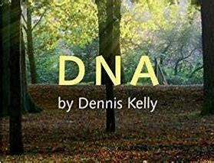**xYear 9 DNA – Knowledge Organiser**

**Key words**: naturalism, subtext, blocking.

**Five key skills** – voice, gesture, movement, facial expressions, and interaction.