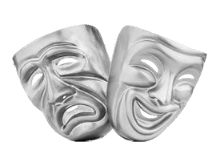
PERFORMING ARTS
KNOWLEDGE ORGANISERS

GREEK THEATRE Year 7 Autumn Term
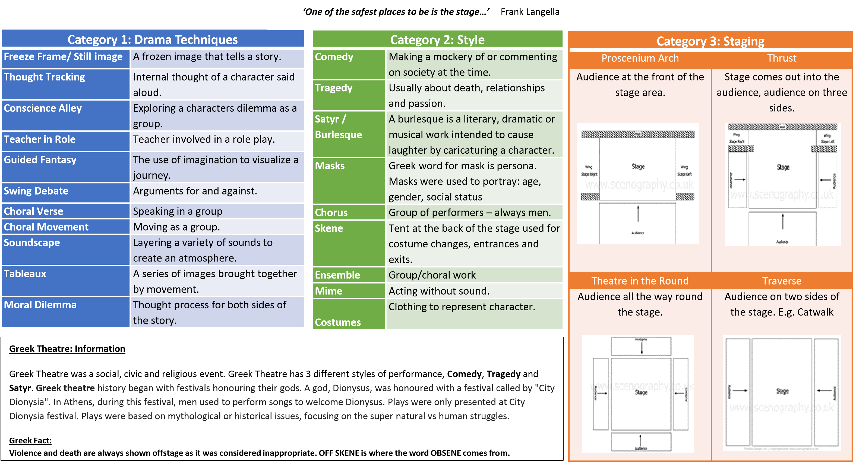

COMMEDIA DELL’ARTE Year 7 Spring Term
“The actor never works alone, there must be a constant awareness of the whole cast, they are literally in it together.” Mazzoni
Category 1:Commedia Dell’Arte |  |  | Melodrama |  |  | Category 2: Pantomime Information
- Italian Comedy 16thto 18th Century– strong sense of ensemble.  - Commedia Dell’Arte means comedy of artists.  - Use of masks means emotion needs to be shown through body language.  - Minimal set.  - Props used – food, furniture, weapons etc.  - Leaps, tumbles, slapstick used.  - Stock characters and archetypes: Villain, Soldier, Pompous doctor, clown, the lovers, gossipy old woman, ballerina servant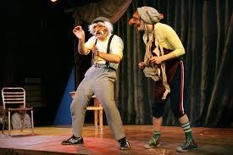 |  |  | - Melodrama is a genre that emerged in France during the revolution period.  - Melodrama means music drama.  - Popular in the 19th Century  - Stereotypical characters (hero, heroine, villain, villain’s sidekick,) interpersonal conflict.  - Over-the-top- and melodramatic! Sensationalises events.  - Dramatic work that exaggerates plot and characters in order to appeal to the emotions.  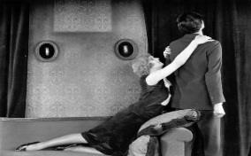 |  |  | - Pantomime is based on a fairy-tale.  - Usually performed at Christmas time.  - Pantomime ‘dame’ is a man in drag.  - Lots of audience participation ‘it’s behind you...oh no it isn’t’! Breaking of the 4th Wall to entertain.  - Heroes enter stage right (heaven), villains enter stage left (hell)  - Use of slapstick, music and dance – very over the top.  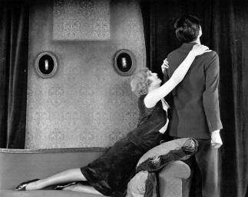  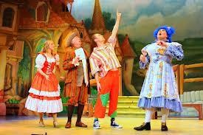  - Comedy and humour used to engage and entertain the audience.
Key Skills & Techniques |  |  | Key Skills & Techniques |  |  | Key Skills and Techniques
1. Characterisation | Facial Expressions, Posture, Body language, Gestures, and  Stance. |  | 1. Characterisation | Facial Expressions, Posture, Body language, Gestures, and  Stance. |  | 1. Vocal skills | Articulation, volume, tone, pitch
 |  |  |  |  |  | 2. Audience  Participation | Speaking to the audience, involving the audience, call and response.
2. Ensemble | Working as a group |  | 2. Melodramatic | Exaggerated movements and voice
3. Movement | Travelling across the space
 |  |  |  |  |  | 3. Slapstick | Over exaggerated silly humour.
 |  |  | 3. Mannerism | An action specific to character
4. Improvisation | Acting on the spot without preparation. |  | 1. Vocal skills | Articulation, volume, tone, pitch |  | 4.Characterisation | Facial Expressions, Posture, Body language, Gestures, and Stance.
http://www.nationaltheatre.org.uk/backstage/comme dia-dellarte |  |  | http://www.youtube.com/watch?v=xAf-6JDw1eU |  |  | http://www.youtube.com/watch?v=adb3Sfo__nE

SHAKESPEARE Year 7 Summer Term
“…and though she be but little, she is fierce” Shakespeare

Category 1: Drama Techniques
Freeze Frame/ Still image A frozen image that tells a story.
Thought Tracking Internal thought of a character said aloud.
Hot Seating Asking questions to explore
character.
Teacher in Role Teacher involved in a role play.
Guided Fantasy The use of imagination to visualize a journey.
Swing Debate Arguments for and against.
Choral Verse Speaking in a group Choral Movement Moving as a group.
Soundscape Layering a variety of sounds to create an atmosphere.
Tableaux A series of images brought together by movement.
Whoosh Performance format to explore
characters
Shakespeare Information:
Category 3: Skills
Physical Acting Skills | Vocal Skills
Facial Expressions (Face)  Posture (Shoulders)  Body Language (Emotion)  Gestures (Hands)  Stance (Legs)  Movement (Walk) | Tone (Emotion)  Volume (Loud)  Pitch (High or Low)  Accent (Location)  Pace (Speed

Category 2: Style
Comedy Always has a good ending
Tragedy Usually about death, relationships and passion.
Trap Door In the floor of the stage to allow actors to disappear.
Category 4: Stage Directions
Upstage
Right
Upstage
Left
Downstage
Centre
Downstage
Right
Downstage
Left
Centre
Stage
Centre
stage
Right
Centre
Stage
Left
Upstage
Centre
AUDIENCE
Backstage An area where actors would be hidden.
Chorus Group of performers
Ensemble Group/choral work
Proxemics Space to show relationships
Levels Heights to show status or power Costumes Clothing to represent character.
Script A written text to be physically performed.

William Shakespeare (baptised 26 April 1564 – 23 April 1616)was an English poet, playwright and actor, widely regarded as the greatest writer in the English language and the world's greatest dramatist. He is often called England's national poet.
Shakespeare was born and raised in Stratford-upon-Avon, Warwickshire. At the age of 18, he married Anne Hathaway, with whom he had three children: Susanna and twins Hamnet and Judith. Sometime between 1585 and 1592, he began a successful career in London as an actor, writer, and part-owner of a playing company called the Lord Chamberlain's Men.
His plays include, The Tempest, Macbeth, Hamlet and Romeo and Juliet.

NATURALISM Year 8 Autumn Term
‘The language of the body is the key that can unlock the soul’ Konstantin Stanislavski 1863- 1938
Category 1: Skills Category 2: Rehearsal Techniques  Volume How loud or quiet you speak Emotional memory An actor recalls own experiences of a physical, mental or emotional time and uses this in character  Tone Matching mood or emotion  Pace How fast or slow you speak Circle of Attention The more focused the actor is on the stage, the more focused the audience are on the play  Pitch How high or low you speak  Body Language How you use your body to show something Improvisation Created spontaneously or without preparation  Gestures How you use your hands to communicate Magic if / imagination Think about what you would do if you were in the characters situation  Facial Expressions How you use your face to communicate an emotion Given circumstance What, Who, When, Where, How and why of the character  Super Objective What are you trying to show about the character? What’s their objective  Stage directions Where on the stage you are positioned  Relaxation Used to remove tension and relax muscles, in preparation for acting  Movement Using the whole stage | Category 3: Staging  1.Lighting The use of lights to create a particular atmosphere  2.Sound Adding sound or music to create an effect  3.Costume What the character would wear  4.Props Items used within the performance  5.Set Backdrops and items to create an atmosphere  6.4th Wall A naturistic production will be solid, three dimensional, and most often in a proscenium theatre that enhances the sense of that fourth wall, creating the illusion of real life being played out.
 | 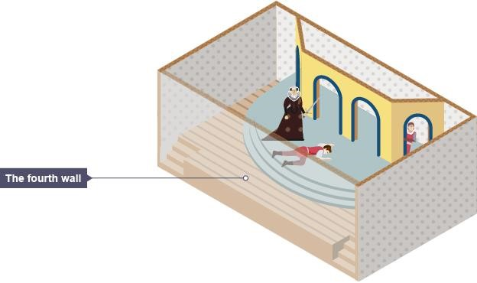
Category 4: NATURALISTIC ACTING
Konstantin Stanislavski is one of the greatest and most influential of modern theatre practitioners. The main thing to remember is that he takes the approach that the actors should really inhabit the role that they are playing. So the actor shouldn’t only know what lines he needs to say and the motivation for those lines, but also every detail of that character’s life offstage as well as onstage. In this way we can establish Stanislavski as a director and practitioner whose productions are naturalistic. Lee Strasberg was inspired by Stanislavski to develop his Method acting techniques!
STANISLAVSKI Fact- Many actors use his Naturalistic techniques when preparing for film roles, for example: Angelina Jolie,
Scarlett Johansson and Steve Buscemi

EPIC THEATRE Year 8 Spring Term
‘Show the character; don’t be the character’ BERTOLT BRECHT 1898- 1956
Category 1: Skills  Articulation How you pronounce your words  Tone Matching mood or emotion  Stance How you stand in role as a character  Posture The position of a person's body when standing or sitting  Body Language How you use your body to communicate feelings  Gestures How you use your hands to communicate  Facial Expressions How you use your face to communicate an emotion  Mannerisms A character trait, repeated action | Category 2: Rehearsal Techniques  Educate A message within the play that comments upon society  V Effect Distance the audience from the characters so they can see what is happening; they can think  Gest An attitude to convey an emotion expressed in words  Direct Address Speaking directly to the audience breaks the fourth wall and destroys any illusion of reality.  Montage The juxtaposition of ideas, images, scenes back to back to provoke thought  Spass (FUN) Brecht introduced songs and comical elements into his plays  Slow motion Actors move around the stage at a reduced speed- to highlight key moments | Category 3: Staging  1.Lighting The use of lights to create a particular atmosphere  2.Sound Adding sound or music to create an effect  3.Costume What the character would wear  4.Props Items used within the performance  5.Set Backdrops and items to create an atmosphere  6.4th Wall A naturistic production will be solid, three dimensional, and most often in a proscenium theatre that enhances the sense of that fourth wall, creating the illusion of real life being played out.  7. Placards A placard is a sign or additional piece of written information presented onstage. Using placards might be as simple as holding up a card or banner.
Category 4: EPIC THEATRE
Bertolt Brecht was a theatre practitioner. Modern theatre owes a lot to his methods. When naturalistic theatre was at its height and acted as a mirror to what was happening in society, he decided to use it as a force for change. He wanted to make his audience think and famously said that theatre audiences at that time “hang up their brains with their hats in the cloakroom”.
He wanted his audiences to remain objective and distant from emotional involvement so that they could make considered and rational judgements about any social comment or issues in his work. To do this he used a range of theatrical devices or techniques so that the audience were reminded throughout that they were watching theatre; a presentation of life, not real life itself. His kind of theatre was called Epic theatre. He called the act of distancing the audience from emotional involvement the verfremdungseffekt or V Effect

PHYSICAL THEATRE Year 8 Summer Term
‘We began with little more than a fierce work ethic and a desire to do it differently.’ Frantic Assembly
Category 1: Skills Category 2: Rehearsal Skills  Balance An even distribution of weight enabling the performer to stay stable. Unison/ Choral Movement When actors move at the same time to create a bigger effect.  Exaggeration To make movements bigger and ‘over the top’.  Stamina The ability to sustain prolonged physical or mental effort.  Contact Eye contact to either look at each other or physically touch.  Pace How fast or slow you move.  Spatial awareness Being aware of what’s around you whether its actor or set. Lift Work To direct or carry from a lower to a higher position; raise: lift one's eyes; lifted the suitcase.  Body Language How you use your body to communicate an emotion .  Repetition To repeat move again and again to create emphasis.  Gestures How you use your hands to communicate.  Canon, ripple To use the same movement and have another actor copy, (Domino)  Facial Expressions How you use your face to communicate an emotion.  Symbolism A symbol implies a greater meaning than the literal suggestion. Symbolism in the theatre can be achieved via characters, colour, movement, costume and props.  Stage directions Where on the stage you are positioned.  Movement Travelling creatively around the space or changing position. | Category 3: Practitioners  1.Steven Burkoff Extreme physicality  2.Frantic Assembly Devising process  3.Jacques Lecoq Mime  4.DV8 Social, Political messages
 | 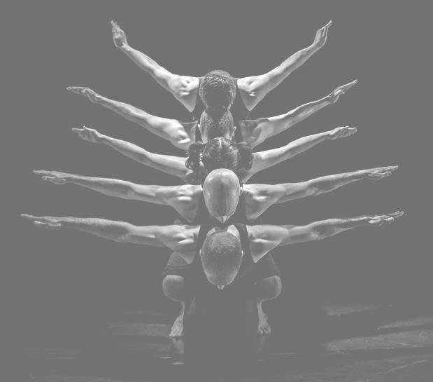
Category 4: Physical Theatre
Physical Theatre is genre of theatrical performance that encompasses storytelling primarily through physical movement. Although several performance theatre disciplines are often described as "physical theatre," the genre's characteristic aspect is a reliance on the performers' physical motion rather than, or combined with, text to convey storytelling. Performers can communicate through various body gestures (including using the body to portray emotions or objects.

Category 1 – Performance Skills
Emphasis Exaggerating one movement more
than the rest, bigger and louder
Projection Making movements and voice louder
and clearer
Focus Concentration – on task.
Using eye contact to show emotion
Accurate Portray a piece with accuracy of _{interpretation} context, style and theme.
Use of space Using all of the space in performance area
Musicality Being sensitive to music
Facial expression Using your face to portray an emotion
Timing Judgment of when something should
be done
Body Language Using your body to communicate an emotion
Category 4: Devising Keywords

KEY TERMINOLOGY Year 9

Category 2: Acting Skills
Spatial Awareness Being aware of what and who is in the space.
Characterisation Creating an other person through body and voice.
Posture Using your shoulders to portray a character Gesture Using hands to communicate
Stance The way to stand to portray a
character/power
Movement Travelling from one place to another
creatively
Physical Contact Connecting with another through the body
Pitch How high or Low – could show age of
character
Tone Using your voice to portray an emotion
Pace Speed to speak or move
Volume How loud of quiet
Accent Your pronunciation of words to suggest a
location
Stamina Sustaining energy for a period of time
Proxemics Using space to show relationships
Levels Using heights to character or power

Category 3 – Dance Skills
Actions Jumps, Rolls,
Posture Rolling your shoulders back
Balance Remaining stable throughout the body
Alignment The relationship of lines within the body
Coordination Reflection of one body part in the whole body.
Flexibility The range of movement in a joint or muscle.
Strength The force you can create or hold in a movement
Stamina Sustaining energy for a period of time
Extension Stretching and tensing a limb to the end.
Spatial awareness Being aware of what and who is in the space.
Contraction Where a body part becomes smaller.
Reproduce Learning choreography as it is taught.

movement accurately
Isolation Moving a single body part on its own

Stimulus Starting point for a performance. This could be a script, poem, image, object, theme, or keyword.
Motivation Motivation is the reason for people's actions, desires and needs.
Scripts Starting point for the development of new ideas as the groundwork or story is already there for you to build on. There’s a plot, established characters, relationships and themes running throughout the play.
Movement An act of moving- to go to a specified direction or manner, change of position Themes The subject of a talk, piece of a writing, exhibition, play.
Environment Site-specific theatre is any type of theatrical production designed to be performed at a unique, specially adapted location other than a standard theatre.

REPETOIRE Year 9
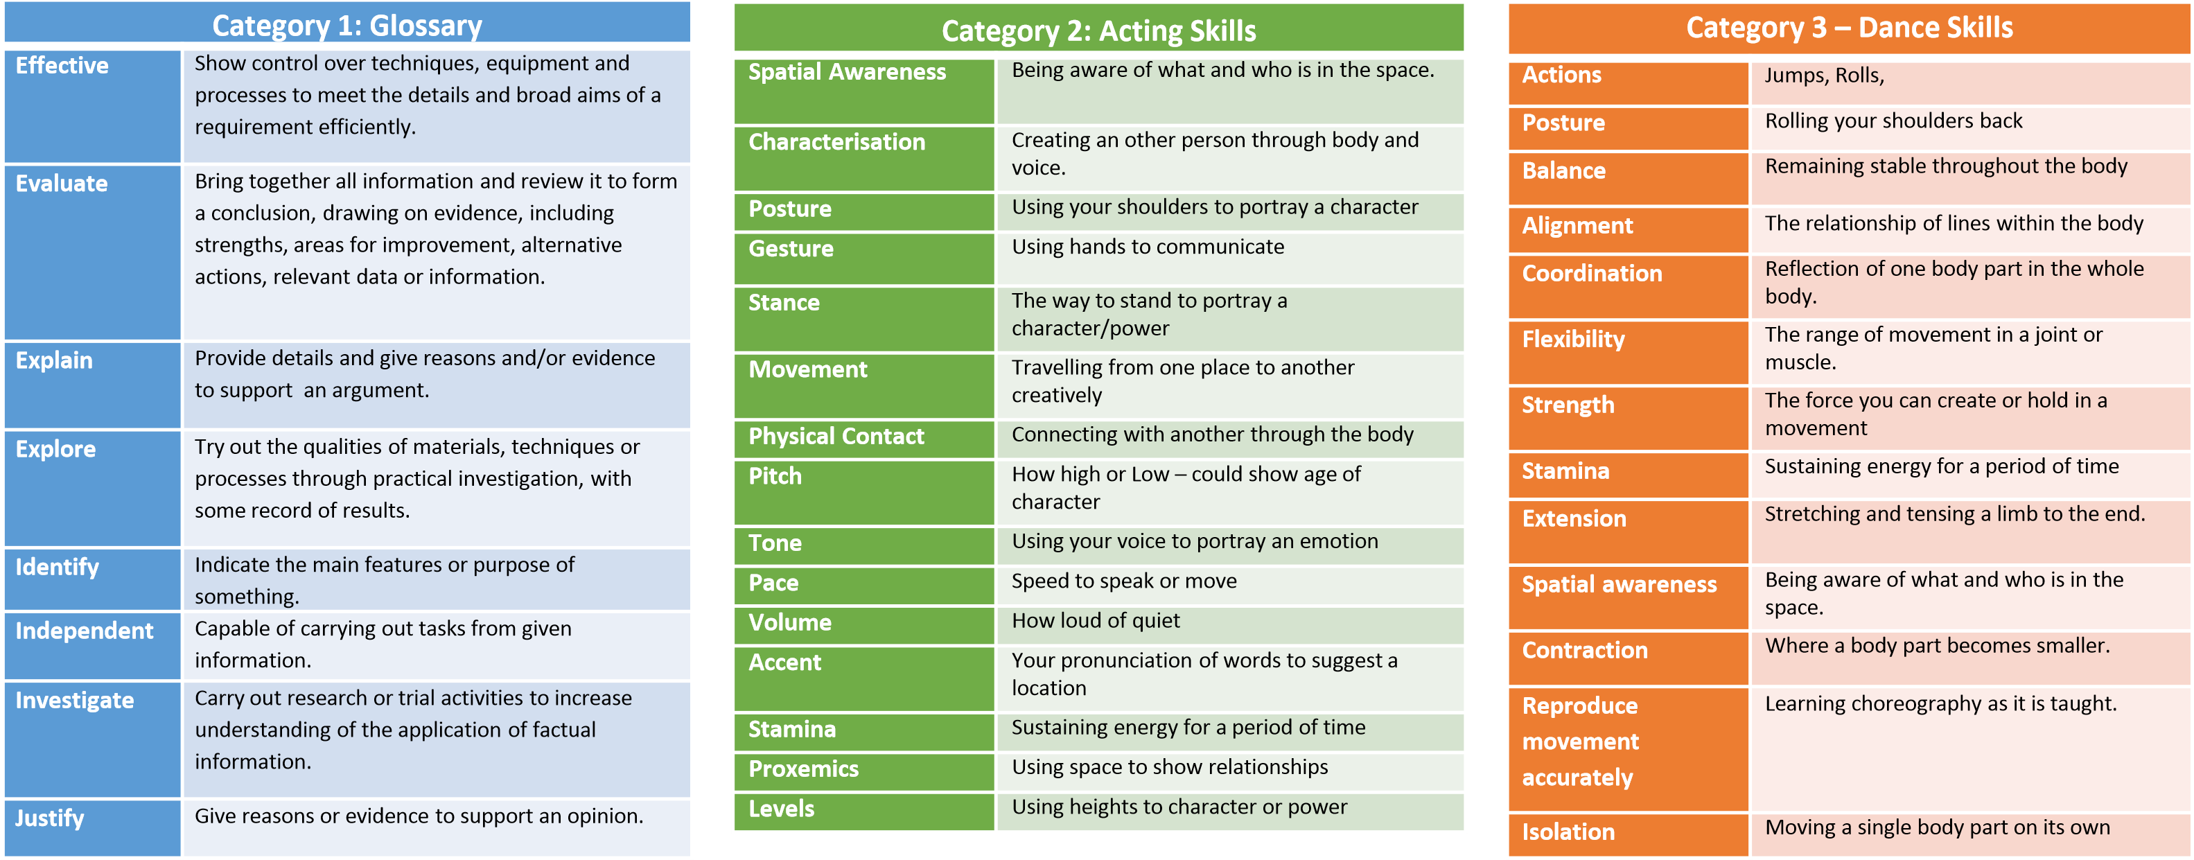
Keywords
1. Acting styles & Genres | Epic, Melodrama, Naturalism, Symbolism, Theatre of Cruelty, Verbatim.
2. Creative intentions | Theme, issue, response to stimulus, style/genre, contextual influences, collaboration with other practitioners, influences by other practitioners.
3. Purpose of performance | To educate, to inform, to entertain, to provoke, to challenge viewpoints, to raise awareness, to celebrate.
4.Performance roles | Actor, Dancer, Singer
5.Non performance roles | Choreographer, Director, Writer, Designer, Costume, Props
6.Responsibilities | Rehearsing, performing, devising, choreographing, directing, writing, managing self.
7.Processes | Responding to stimulus to generate ideas, exploring & developing ideas, discussion with performers, setting tasks, sharing ideas, teaching material, organising and running rehearsals.
PERFORMANCE

Year 9
Category 1 – IDEAS  1. Antagonist A person or a situation that opposes another character’s goals or desires  2. Blocking The planning and working out of the movements of actors on stage.  3. Conflict Opposition of persons or forces giving rise to dramatic action.  4. Crisis A decisive point in the plot of a play on which the outcome of the remaining action depends  5. Character A personality or role an actor/actress re-creates.  6. Devising Creating drama from a stimuli  7. Dialogue The conversation between actors on stage.  8. Soliloquy Speech delivered by a character who is alone on the stage; utters thoughts aloud, a way to inform the audience of his/her motivations and state of mind.  9. Epilogue A summary speech delivered at the end of a play that explains or comments on the action  10. Interpretation How the director or actor portrays the script  11. Levels Gives status/ Power to an actor ie; A king would also sit higher than a servant  12. Scene The section/s of the play  13. Protagonist The main character or hero  14. Cue A signal, either verbal or physical, that indicates something else, such as a line of dialogue or an entrance, is to happen. A cue is also used by stage or tech crews.  15. Prologue A speech which introduces the play  16. Plot The events of the play (the storyline)  17. Climax The point of greatest dramatic tension or transition in a theatrical work.  18. Adlib To improvise lines that are not part of the written script; also refers to the improvised line | Category 2 – EVALUATION  Idea: The concept and style of performance, your selection of target audience, how the ideas meet the requirements of the brief, the resources needed (during development and performance), for the exploration and development of ideas, your contribution to the exploration and development of ideas and how the work of practitioners has influenced your ideas.  Skills: Your role in the group, the skills and techniques you selected, how your skills meet the requirements of the brief, how you developed your skills and techniques, your individual contribution to the rehearsal/development process, how the work of practitioners has influenced your development of skills and techniques.  Evaluation: How the outcome met the requirements of the brief, the development process as an individual and as a group, the performance/design outcome, the key strengths of your work, areas for further development.
 | Category 3 – Choreography Techniques
Canon | Like a Canon on a boat, one dancer begins routine, at a certain point the 2nd dancer begins routine from the beginning and so on.
Unison | In time, In sync – all dancers as one
Levels | Completing choreography at different levels
Accumulation | One dancer begins and in turn the rest join in
Dynamics | Changing the speed and the fluidity in a movement

